THE REFLECTION OF ALFRED ADLER’S AMBITION IN DEAN KOONTZ’S NOVEL SILENT CORNER

TERM PAPER



RONNY MELDIKA ARVIANSYAH
2014130012

STRATA ONE (S-1) OF ENGLISH LANGUAGE AND CULTURE
FACULTY OF HUMANITIES
DARMA PERSADA UNIVERSITY
JAKARTA
2018
THE REFLECTION OF ALFRED ADLER’S AMBITION IN DEAN KOONTZ’S NOVEL SILENT CORNER

TERM PAPER
Submitted in Part Fulfilling for Obtaining
Strata One (S-1) Degree

RONNY MELDIKA ARVIANSYAH
2014130012

STRATA ONE (S-1) OF ENGLISH LANGUAGE AND CULTURE
FACULTY OF HUMANITIES
DARMA PERSADA UNIVERSITY
JAKARTA
2018
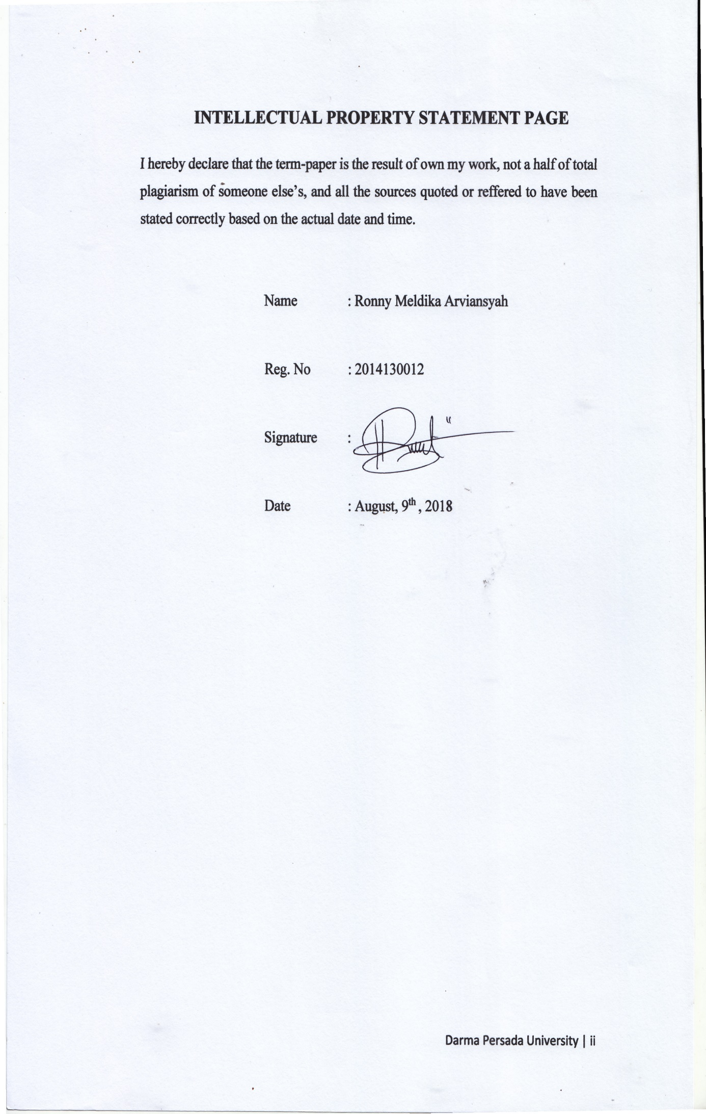

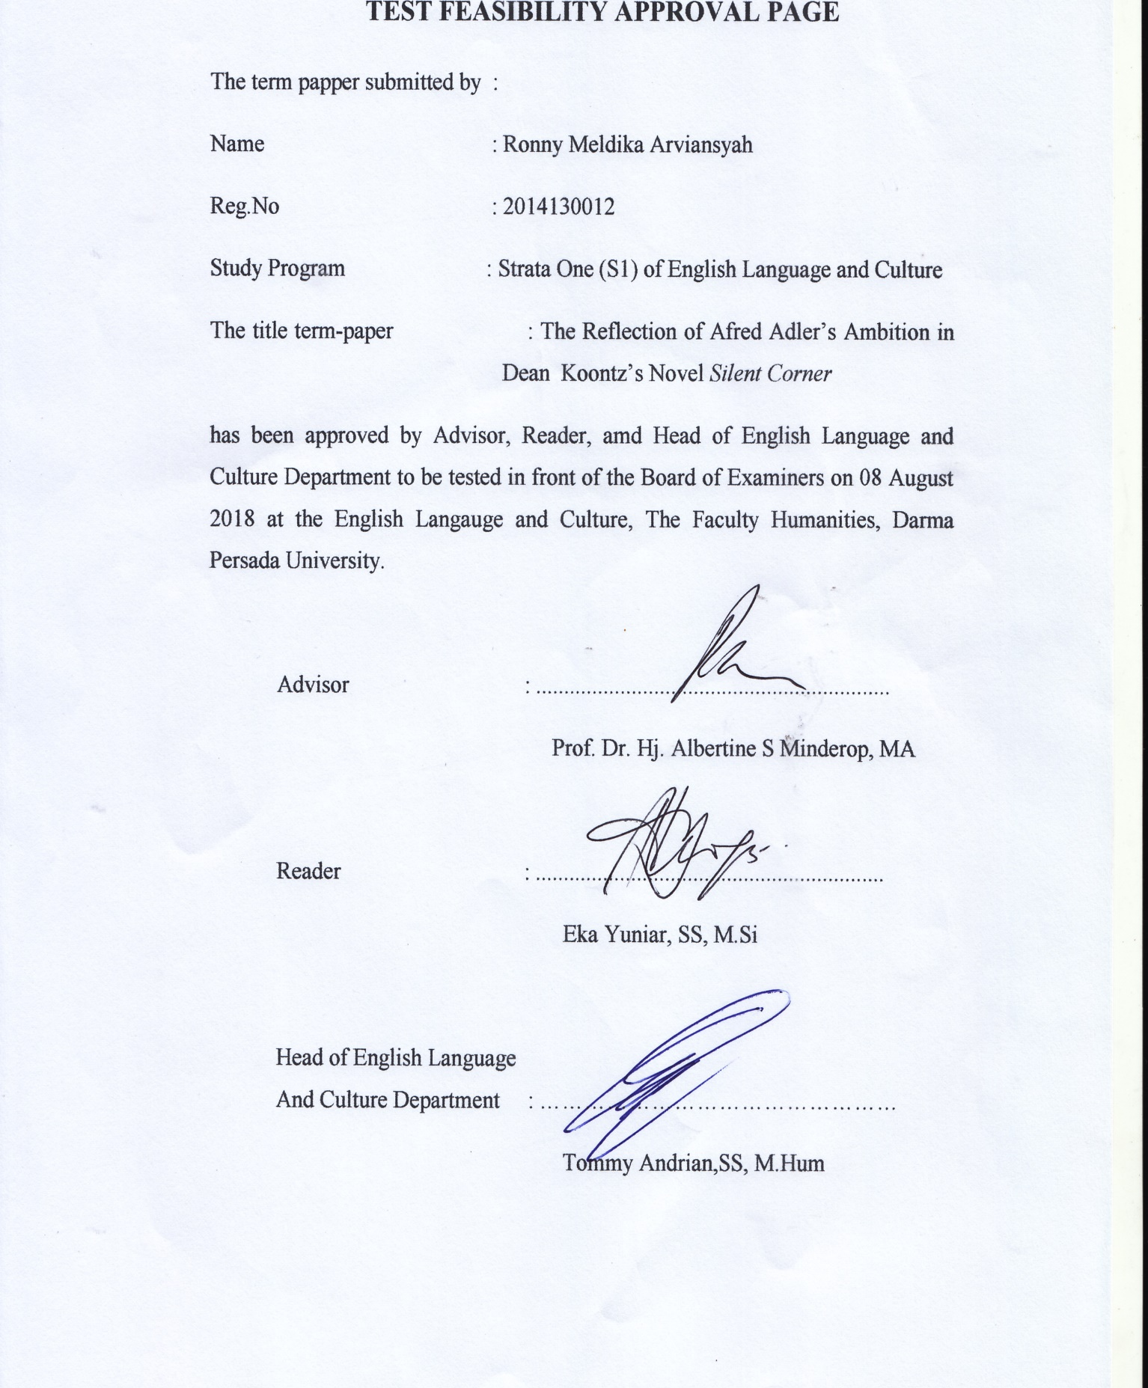

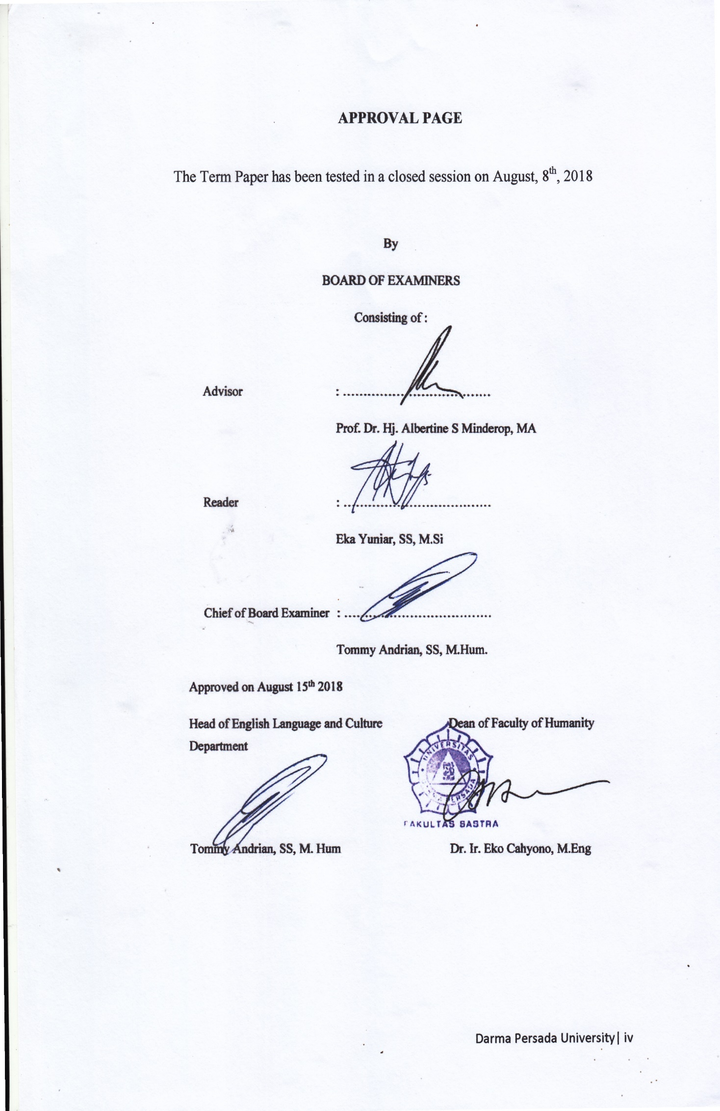

ACKNOWLEDGEMENT
Alhamdulillahi rabbil ‘aalamiin, owing to Allah SWT’s mercy and blessing, finally I could complete this term-paper well, which entilted The Reflection of Alfred Adler’s Ambition a literary study on novel Silent Corner by Dean Koontz.
This term-paper is submitted to the Strata One English Language and Culture of Darma Persada University as a partial fulfillment of the requirements for obtaining the Strata One (S1) degree.
I would like to thank to all parties who have guided and supported me in finishing this term-paper, my appreciation is delivered to those who give contribution in completion of this term-paper, which I listed as follows :
- Prof. Dr. Hj. Albertine S Minderop MA, as the Adviser who has guided and helped me patiently in the preparation of this research.
- Eka Yuniar, SS, M.Si as the Reader and Academic Adviser who has checked and corrected the word by word. Your suggestions in writing has made the beauty of English even visible.
- Tommy Andrian, SS, M.Hum as the Head of English Language and Culture Department.
- All lecturers of English Language and Culture Department who have given me so much knowledge and experiences.
- My dear family, especially my parents Arifin and Novi Hariati who never gives up to make their children get the higher education, then is never tired to remind me to always pray to complete my term paper. Their support cannot be forgotten.
- My special person, Kamilia Nazhara for her support and understanding during my pursuit of bachelor’s degree that made the completion of this term paper possible. You were always around at times I thought that it was impossible to continue, you helped me to keep things in perspective. Thanks for your unconditional support.
- Bagas Putra as my term paper’s mate who always with me in sadness and in happiness while doing term paper and meeting lovely advisor.
- My friends in Ayam Geprek Sambel Dongo’s Grup, thank you for all your supports and advices. And of course for the laugh which always make me happy.
- My friends in English Language and Culture Department class of 2014 who always support and give many advices for me in every semester. You are the best for me.
Therefore, constructive criticisms are welcome. Overall, I hope that this research can give a bit contribution to the language education, especially to the field of literature, and to further pedagogical research.

Jakarta, 16 July 2018
Writer

Ronny Meldika Arviansyah

ABSTRACT
Name : Ronny Meldika Arviansyah
Program of Study : English Language and Culture
Title : The Reflection of Alfred Adler’s Ambition in Dean Koontz in Dean Koontz’s Novel Silent Corner

This term-paper discusses about the theme of a novel through two approaches, intrinsic and extrinsic approaches, are applied to analyze this novel. The concepts that is applied to analyze through intrinsic approach consists of characterization by using showing methods and telling methods, plot and also setting. The concept to analyze through extrinsic approach is Ambition Theory by Alfred Adler. This research explains about the reflection of Alfred Adler’s Ambition theory in one characters, Jane Hawk, as well as its relation to other intrinsic elements. The term-paper explains about Jane Hawk as person who has ambition to find out who has killed her husband. In this research, Silent Corner novel is the primary sources and supported by some of relevant theories, concepts, and definitions which as secondary sources.
Keywords: Silent Corner, Ambition, Alfred Adler

ABSTRAK
Nama : Ronny Meldika Arviansyah
Program Studi : Bahasa inggris dan budaya
Judul : The Reflection of Alfred Adler’s Ambition in Dean Koontz in Dean Koontz’s Novel Silent Corner

Skripsi ini membahas tema sebuah novel melalui dua pendekatan, yaitu pendekatan intrinsik dan ekstrinsik. Konsep-konsep yang digunakan untuk menganalisis melalui pendekatan intrinsik meliputi karakterisasi melalui metode langsung dan tidak langsung, alur dan juga latar. Konsep untuk menganalisis melalui pendekatan ekstrinsik adalah ambisi dari Alfred Adler. Penelitian ini membahas tentang cerminan teori ambisi dari Alfred Adler dalam satu karakter, yaitu Jane Hawk, serta kaitannya dengan unsur-unsur intrinsik lainnya. Skripsi ini menjelaskan tentang Jane Hawk yang sangat ambisius untuk mencari pembunuh suaminya. Novel Silent Corner merupakan sumber primer dalam skripsi ini dan didukung oleh teori-teori, konsep dan definisi terkait yang menjadi sumber sekunder.
Kata Kunci: Silent Corner, Ambisi, Alfred Adler

TABLE OF CONTENTS

INTELLECTUAL PROPERTY STATEMENT PAGE Error! Bookmark not defined.
TEST FEASIBILITY APPROVAL PAGE Error! Bookmark not defined.
APPROVAL PAGE Error! Bookmark not defined.
ACKNOWLEDGEMENT v
ABSTRACT........ vii
ABSTRAK............... viii
TABLE OF CONTENTS ix
CHAPTER I : INTRODUCTION 1
A. Background of The Problems 1
B. Identification of The Problems 2
C. The Limitation of The Problems 2
D. The Formulation of The Problems 2
E. The Objectives of The Research 3
F. Method of The Research 3
G. Benefit of The Research 3
H. The Systematic Organization of the Reasearch 3
CHAPTER II : FRAMEWORK OF THE THEORIES 5
A. Intrinsic Approaches 5
1. Characterization 5
2. Plot 8
3. Setting 9
4. Theme 10
B. Extrinsic Approaches 10
1. Psychology in Literature 10
2. Social Psychology 10
3. Concept of Ambition 11
CHAPTER III : THE NOVEL SILENT CORNER THROUGH INTRINSIC APPROACHES 16
A. Characterization 16
1. Jane Hawk 16
2. Nick 24
3. Gwyn Lambert 28
4. Jimmy Radburn 30
B. Plot 33
1. Exposition 33
2. Complication 34
3. Crisis 35
4. Falling Action 36
5. Resolution 38
C.Setting 38
1. Setting Background of Action 39
2. Setting as Means Revealing Character 40
3. Setting as Antagonist 41
CHAPTER IV : THE REFLECTION OF ALFRED ADLER’S AMBITION 43
A. Analysis of Ambition Based on Adler’s Theory and
Characterization 43
1. Jane Hawk 44
B. The Relation of Ambition to the Plot 46
1. Expotition for Ambition 46
2. Complication of Ambition 46
3. Crisis of Ambition 47
4. Falling Action of Ambition 48
5. Resolution for ambition 49
C. The Relation of Ambition to the Setting 50
1. Setting Background for Ambition 50
2. Setting An as Antagonist for Mmbition 51
3. Setting as Means Revealing Character for Ambition 51
D.The Reflection of Ambition in Novel Sillent Corner 59
CHAPTER V : CONCLUSION 60
REFERENCES 62
POSTER OF THE RESEARCH... 64
CURRICULUM VITAE 65

