THE UNDERLYING MEANING
IN TOYOTA PRIUS THE LONGEST CHASE ADVERTISEMENT:
A STUDY OF SEMIOTICS

TERM PAPER



IKA RAISA KAMAL
2014130083

STRATA ONE (S-1) OF ENGLISH LANGUAGE AND CULTURE DEPARTMENT
FACULTY OF HUMANITIES
UNIVERSITY OF DARMA PERSADA
JAKARTA
2018

THE UNDERLYING MEANING
IN TOYOTA PRIUS THE LONGEST CHASE ADVERTISEMENT:
A STUDY OF SEMIOTICS

TERM PAPER

Submitted in Partial Fulfillment of the Requirements
for Strata One (S1) Degree

IKA RAISA KAMAL
2014130083

STRATA ONE (S-1) OF ENGLISH LANGUAGE AND CULTURE DEPARTMENT
FACULTY OF HUMANITIES
UNIVERSITY OF DARMA PERSADA
JAKARTA
2018

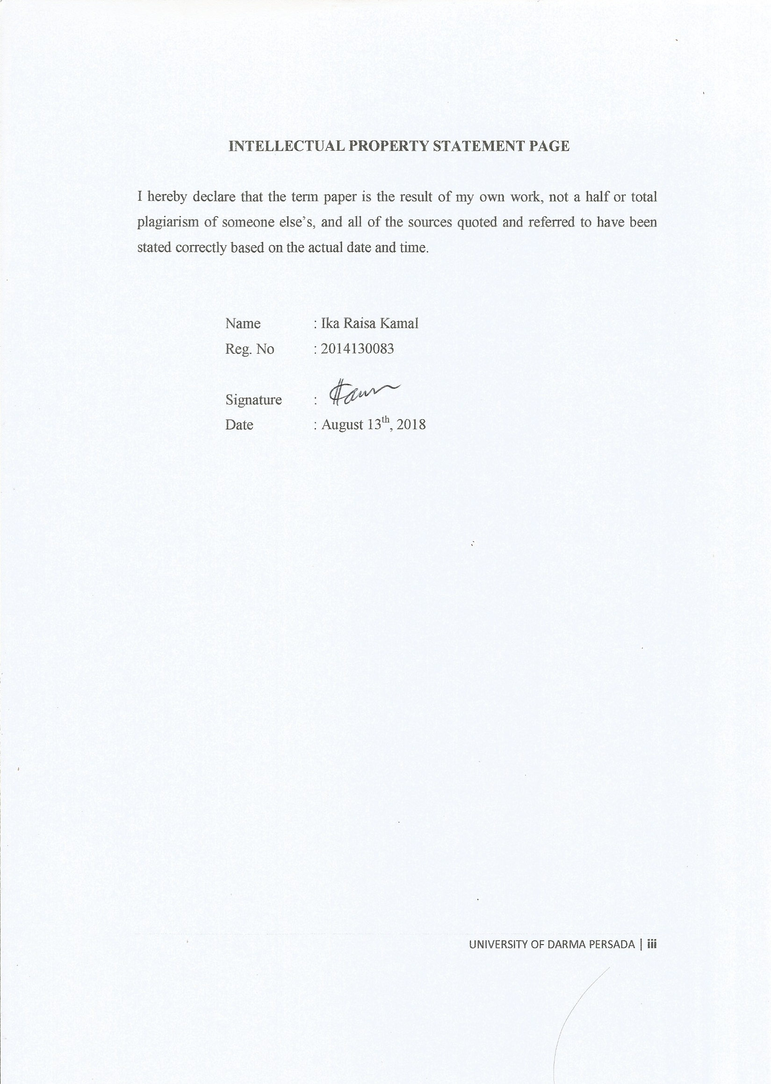

INTELLECTUAL PROPERTY STATEMENT PAGE

I hereby declare that the term paper is the result of my own work, not a half or total plagiarism of someone else’s, and all of the sources quoted and referred to have been stated correctly based on the actual date and time.

Name : Ika Raisa Kamal
Reg. No : 2014130083

Signature :
Date : August 13th, 2018

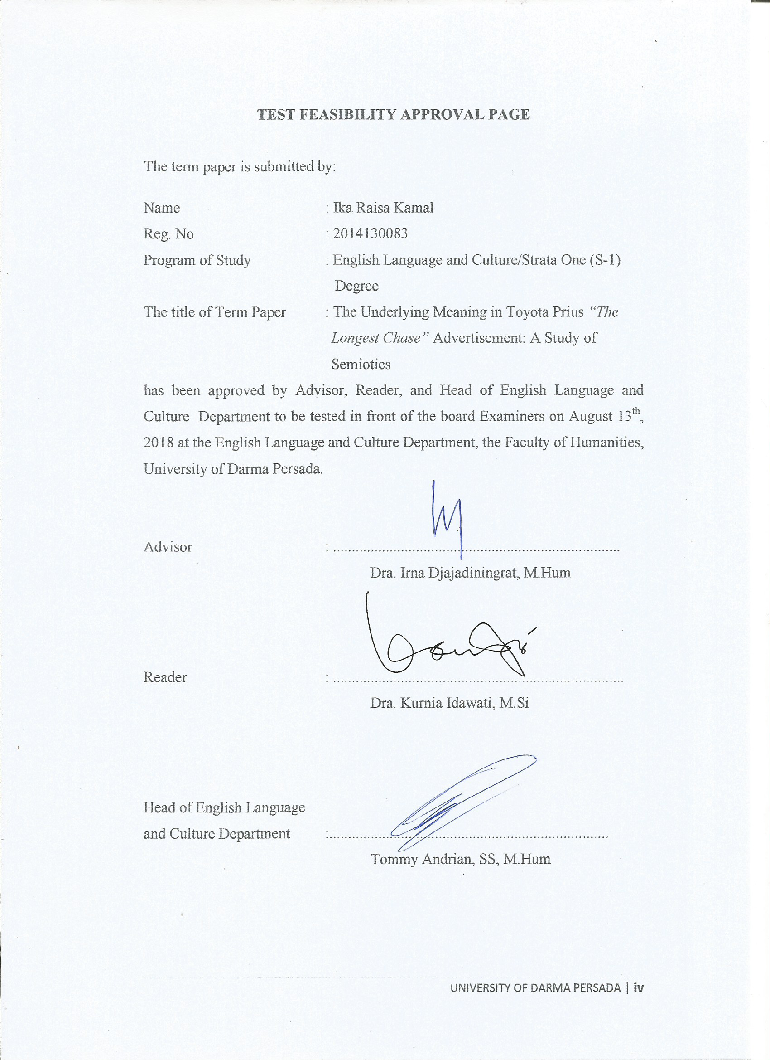
TEST FEASIBILITY APPROVAL PAGE

The term paper submitted by :
Name : Ika Raisa Kamal
Reg. No : 2014130083
Program of Study : English Literature/Strata One Degree (S-1)
The title of Term Paper : THE UNDERLYING MEANING IN TOYOTA PRIUS THE LONGEST CHASE ADVERTISEMENT: A STUDY OF SEMIOTICS
has been approved by Advisor, Reader, and Head of English Language and Culture to be tested in front of the board Examiners on August 13th, 2018 at the English Language and Culture, the Faculty of Humanities, University ofDarma Persada.

Advisor : ............................................................................
Dra. Irna Djajadiningrat, M.Hum

Reader : .............................................................................
Dra. Kurnia Idawati, M.Si

Head of English
Language and Culture :..........................................................................
Tommy Andrian, SS, M.Hum

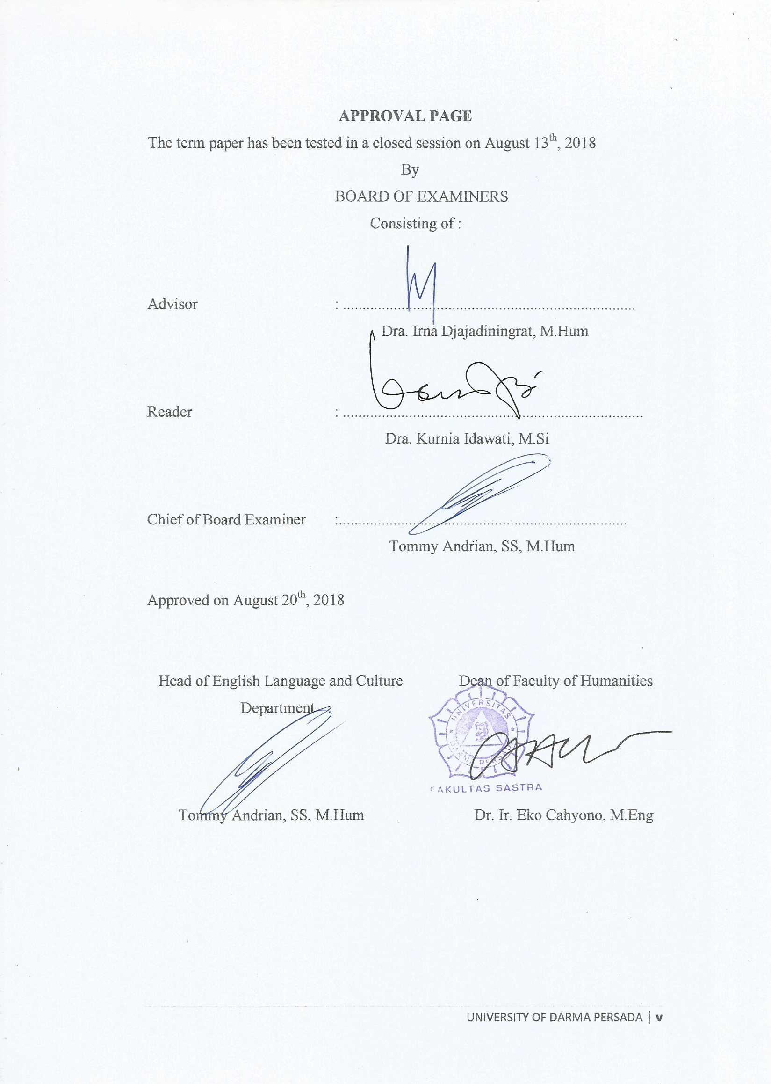
APPROVAL PAGE
The term paper will be tested in a closed session on August 13th, 2018
By
BOARD OF EXAMINERS
Consisting of :

Advisor : ...........................................................................
Dra. Irna Djajadiningrat, M.Hum

Reader : .............................................................................
Dra. Kurnia Idawati, M.Si

Chair of Board Examiners :..........................................................................
Tommy Andrian, SS, M.Hum

Approved on August 20th, 2018

Head of English Language and Culture Dean of Faculty of Humanities

Tommy Andrian, SS, M.Hum Dr. Ir. Eko Cahyono, M.Eng

ACKNOWLEDGEMENT

Alhamdulilaahi rabbil a’laamiin, praise to the Almighty Allah SWT who strengthens and blesses me so I can finally finish this perplexing yet intriguing research entitled “The Underlying Meaning in Toyota Prius “The Longest Chase” Advertisement: A Study of Semiotics” a linguistic study on Roland Barthes’ semiotics approach.
This term-paper is submitted to the Strata One Program, English Language and Culture of Darma Persada University as a partial fulfillment of the requirements for obtaining the Strata One (S1) degree. As the researcher, I realize that myresearch is nowhere near perfect. Nevertheless, I would like to present my sincere gratitude and appreciation to superbpersons behind the making of this term-paper who help, cheer, and patiently guide me, as listed as follow:
- Dra. Irna Djajadiningrat, M.Hum, as the advisor of my term paper, who has given me her supervision and advice, trusted me to continue this term paper even I need to add one more semester, and guide me from the very early stage of this research as well as giving me extraordinary experiences since the third semester. Thank you very much, Mam.
- Dra. Kurnia Idawati, M.Si, as the reader of this term paper, who has not only correcting my grammar error but also given me a lot of suggestion and helped me getting out of the dark. Thank you, Mam.
- Tommy Andrian, SS, M. Hum as the Head of English Language and Culture and the Chair person of Examiner for his counselling and crucial contribution in the improvement of the result of this term paper.
- Widyastuti, S.Pd as the academic advisor who patiently guides me a lot of lessons from the first semester until the last.
- Dr. Ir. Eko Cahyono, M.Eng as the Dean of Faculty of Humanities.
- All precious lecturers in English Language and Culture who have taught and help me a lot throughout the past few years. Thank you for giving me knowledge and experiences.
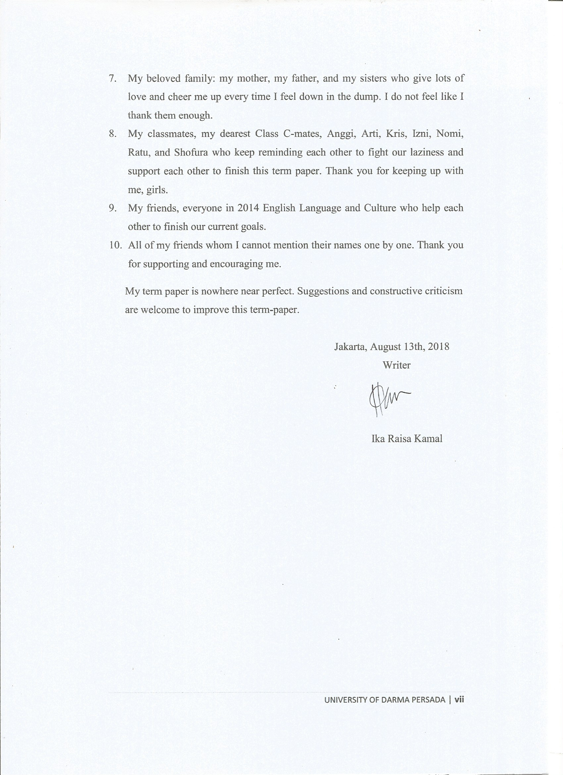
- My beloved family: my mother, my father, and my sisters who give lots of love and cheer me up every time I feel down in the dump. I do not feel like I thank them enough.
- My classmates, my dearest Class C-mates, Anggi, Arti, Kris, Izni, Nomi, Ratu, and Shofura who keep reminding each other to fight our laziness and support each other to finish this term paper. Thank you for keeping up with me, girls.
- My friends, everyone in 2014 English Language and Culture who help each other to finish our current goals.
- All of my friends whom I cannot mention their names one by one. Thank you for supporting and encouraging me.
My term paper is nowhere near perfect. Suggestions and constructive criticism are welcome to improve this term-paper.

Jakarta, August 13th, 2018
Writer

Ika Raisa Kamal

ABSTRACT
Name : Ika Raisa Kamal
Registration Number : 2014130083
Program of Study : English Language and Culture Department
The title of the term paper : The Underlying Meaning in Toyota Prius “The
Longest Chase” Advertisement: A Study of Semiotics

Advertisements nowadays contain messages that need to be interpreted, the purpose is not only promoting a product but also giving hidden message about the brand. This research discusses about the underlying meaning in Toyota Prius “The Longest Chase” advertisement. Using the theory of Semiotician Roland Barthes about sign, the aim of this research is to find out the concealed message in this advertisement. This research uses qualitative method by the virtue of Roland Barthes’ denotation, the literal meaning, and connotation, the real meaning behind of the something that can be seen as denotation. Each scene has its own denotative and connotative meanings which arouse images about the product and lead the advertisement to reveal the hidden message.

Keywords : Advertisement, Semiotics, Denotation, Connotation, Message.

ABSTRAK
Nama : Ika Raisa Kamal
NIK Mahasiswa : 2014130083
Program Studi : Bahasa dan Kebudayaan Inggris
Judul Skripsi : The Underlying Meaning in Toyota Prius “The
Longest Chase” Advertisement: A Study of Semiotics

Iklan saat ini mengandung pesan yang perlu ditafsirkan, tujuannya tidak hanya untuk mempromosikan produk tetapi juga untuk memberikan pesan tersembunyi tentang merek tersebut. Penelitian ini membahas tentang makna yang mendasari iklan Toyota Prius “The Longest Chase”. Menggunakan teori Semiotikian Roland Barthes tentang tanda, tujuan dari penelitian ini adalah untuk mengetahui pesan tersembunyi dalam iklan ini. Penelitian ini menggunakan metode kualitatif dengan berdasarkan denotasi, makna literal, dan konotasi, makna sebenarnya di balik sesuatu yang dapat dilihat, dari teori Roland Barthes. Setiap adegan memiliki makna denotatif dan konotatifnya sendiri yang menimbulkan citra tentang produk dan mengungkap pesan tersembunyi di dalam iklan.
Kata Kunci: Iklan, Semiotika, Denotasi, Konotasi, Pesan.

TABLE OF CONTENTS
Page
PAGE OF TITLE ii
INTELLECTUAL PROPERTY STATEMENT PAGE iii
TEST FEASIBILITY APPROVAL PAGE iv
APPROVAL PAGE v
ACKNOWLEDGEMENT vi
ABSTRACT viii
ABSTRAK ix
TABLE OF CONTENTS x
CHAPTER 1: INTRODUCTION 1
1.1 Background of the Problem 1
1.2 Identification of the Problem 3
1.3 Limitation of the Problem 4
1.4 Formulation of the Problem 4
1.5 Objective of the Research ……. 4
1.6 Method of the Research 5
1.7 Benefits of the Research 5
1.8 Systematic Organization of the Research 5
CHAPTER 2: FRAMEWORK OF THE THEORIES 7
2.1 Definition of Advertisement 7
2.2 The Order of Signification 8
2.3 Denotation ... 10
2.4 Connotation 11
2.5 The Meaning of Color 12

CHAPTER 3: THE UNDERLYING MEANING IN TOYOTA PRIUS
THE LONGEST CHASE ADVERTISEMENT:
A STUDY OF SEMIOTICS 18
3.1 Denotative and Connotative Analysis
in the Advertisement................. 20
3.1.1 The Analysis of Scene 1 20
3.1.1.1 Denotation and Connotation from Scene 1 21
3.1.2 The Analysis of Scene 2 24
3.1.2.1 Denotation and Connotation from Scene 2 24
3.1.3 The Analysis of Scene 3 27
3.1.3.1 Denotation and Connotation from Scene 3 28
3.1.4 The Analysis of Scene 4 30
3.1.4.1 Denotation and Connotation from Scene 4 31
3.1.5 The Analysis of Scene 5 38
3.1.5.1 Denotation and Connotation from Scene 5 39
3.1.6 The Analysis of Scene 6 42
3.1.6.1 Denotation and Connotation from Scene 6 42
3.1.7 The Analysis of Scene 7 47
3.1.7.1 Denotation and Connotation from Scene 7 47
3.1.8 The Analysis of the Color 49
3.1.9 The Analysis of the Logo and the Taglines 50
3.1.9.1 The Analysis of the Logo 50
3.1.9.2The Analysis of the Taglines 53
3.2 The Image Built in the Advertisement................. 54
3.2.1 The Image Built in Scene 1 54
3.2.2 The Image Built in Scene 2 54
3.2.3 The Image Built in Scene 3 55
3.2.4 The Image Built in Scene 4 55
3.2.5The Image Built in Scene 5 56
3.2.6 The Image Built in Scene 6 56
3.2.6 The Image Built in Scene 7 56
3.3 The Message Conveyed in the Advertisement................. 57
CHAPTER 4: CONCLUSION 59
SCHEME OF THE RESEARCH 61
POSTER OF THE RESEARCH 62
REFERENCES 63
CURRICULUM VITAE 65

