SCHEME OF THE RESEARCH
TITLE OF THE RESEARCH:
CLARA SOLBERG’S SITUATIONAL DEPRESSION IN MARY KUBICA’S NOVEL EVERY LAST LIE

INTRINSIC APPROACHES
EXTRINSIC APPROACH
Characterization
Setting
Psychological approach
Plot
- Setting as A Background of Action
- Setting as An Antagonist
- Setting as A Means of Revealing Character

- Exposition
- Complication
- Crisis
- Falling Action
- Resolution
- Showing Method:
- Characterization through Dialogue
- Characterization through Action
- Telling Method:
- Characterization through Appearance
- Characterization by the Author

Situational Depression Theory

TITLE OF THE RESEARCH:
CLARA SOLBERG’S SITUATIONAL DEPRESSION IN MARY KUBICA’S NOVEL EVERY LAST LIE

POSTER OF THE RESEARCH
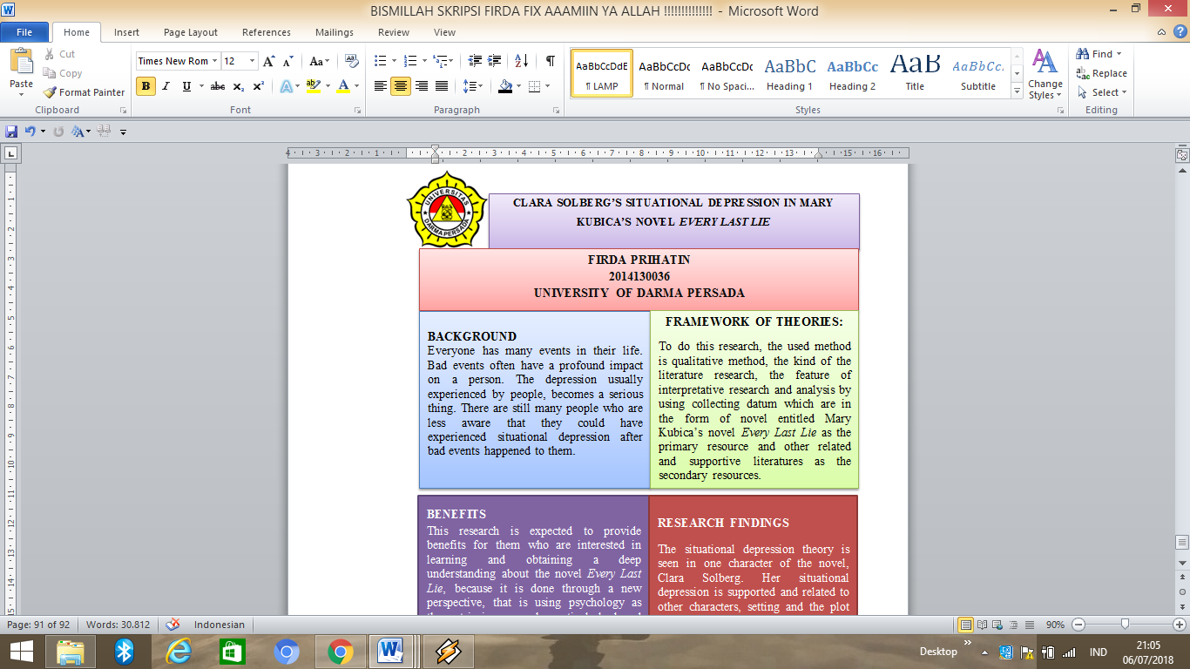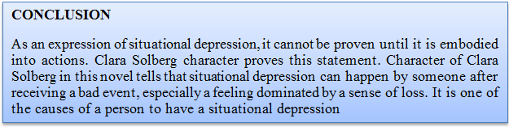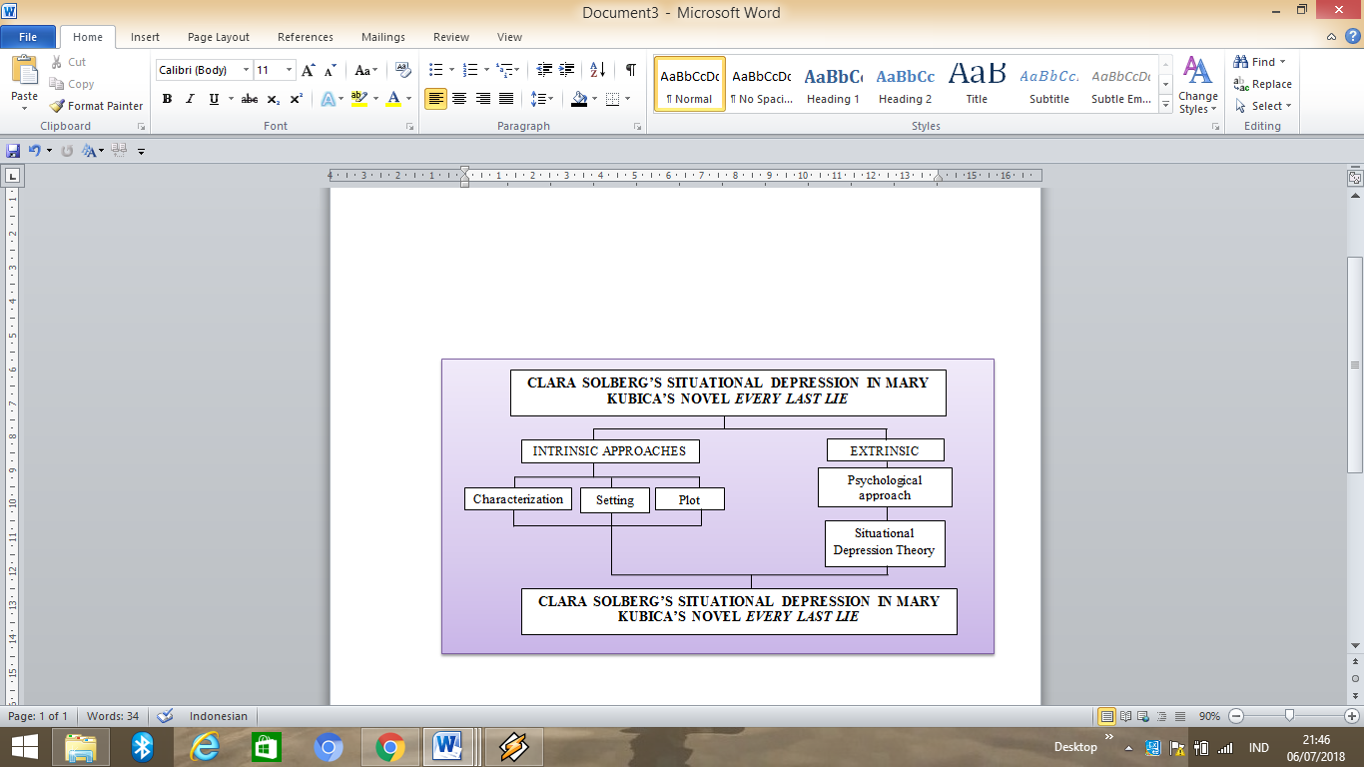
CURRICULUM VITAE


Name : Firda Prihatin
Nationality : Indonesian
Sex : Female
Place/Date of Birth : Jakarta, July 9, 1996
Address : Jl. Baru Cakung Cilincing No. 76 RT 003/004
Kelurahan Cakung Barat
Kecamatan Cakung Jakarta Timur
Phone/Fax : 089622484436
E-mail : firdaprihatin@gmail.com

EDUCATIONAL BACKGROUND
2002-2008 : 03 PAGI National Elementary School, Jakarta
2008-2011 : 144 National Junior High School, Jakarta
2011-2014 : 8 National Islamic Senior High School, Jakarta
2014-Present : University of Darma Persada

ACHIEVEMENT
2004 : 3rd winner of Pidato Antar SD Negeri Sekelurahan
2013 : 3rd winner of Three Languages Speech in Bulan Bahasa
2014 : 1st winner of Writing Poetry in Ajang Kreativitas Siswa
2018 : Participant of Lomba Cipta Puisi Event Hunter Indonesia
2018 : Certificate TOEIC

ATTACHMENT






