CLARA SOLBERG’S SITUATIONAL DEPRESSION
IN MARY KUBICA’S NOVEL EVERY LAST LIE

TERM PAPER



By
FIRDA PRIHATIN
2014130036

STRATA ONE (S-1) OF ENGLISH LANGUAGE AND CULTURE DEPARTMENT
FACULTY OF HUMANITIES
UNIVERSITY OF DARMA PERSADA
JAKARTA
2018

CLARA SOLBERG’S SITUATIONAL DEPRESSION
IN MARY KUBICA’S NOVEL EVERY LAST LIE

TERM PAPER
Submitted in Part Fulfilling for Obtaining
Strata One (S-1) Degree

By
FIRDA PRIHATIN
2014130036

STRATA ONE (S-1) OF ENGLISH LANGUAGE AND CULTURE DEPARTMENT
FACULTY OF HUMANITIES
UNIVERSITY OF DARMA PERSADA
JAKARTA
2018

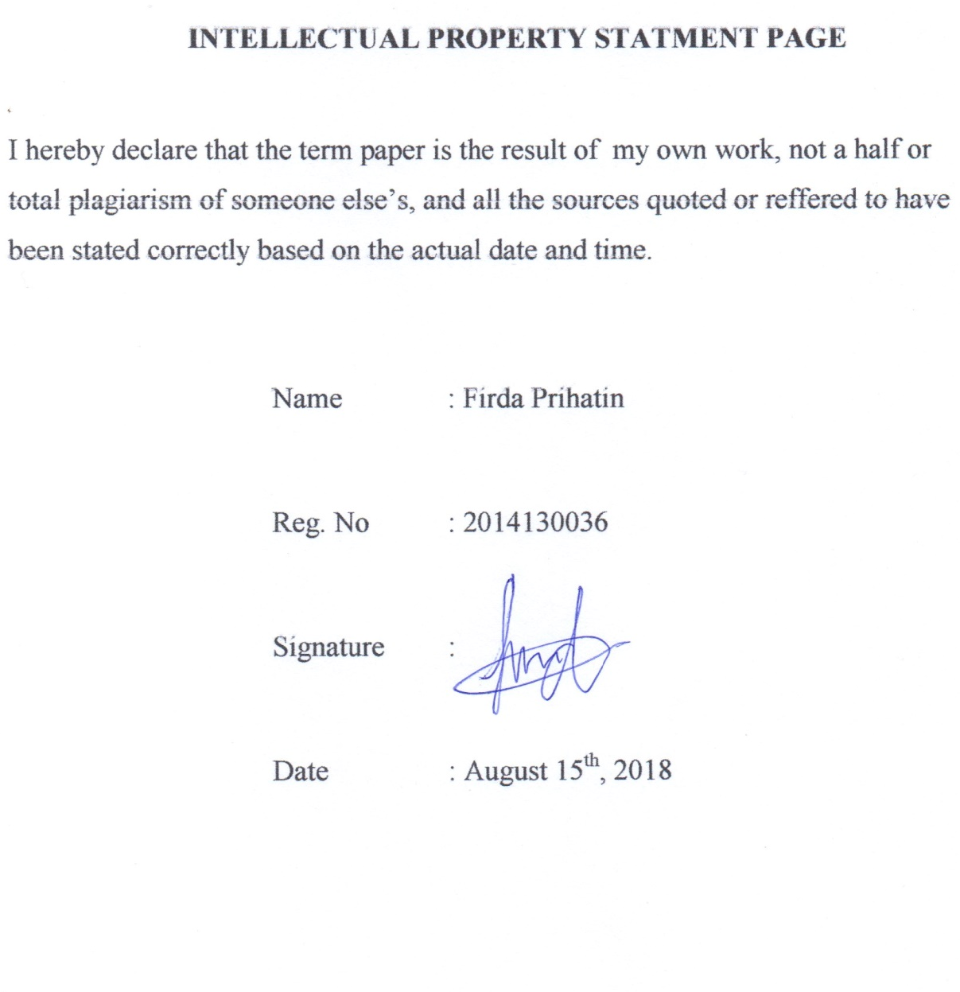

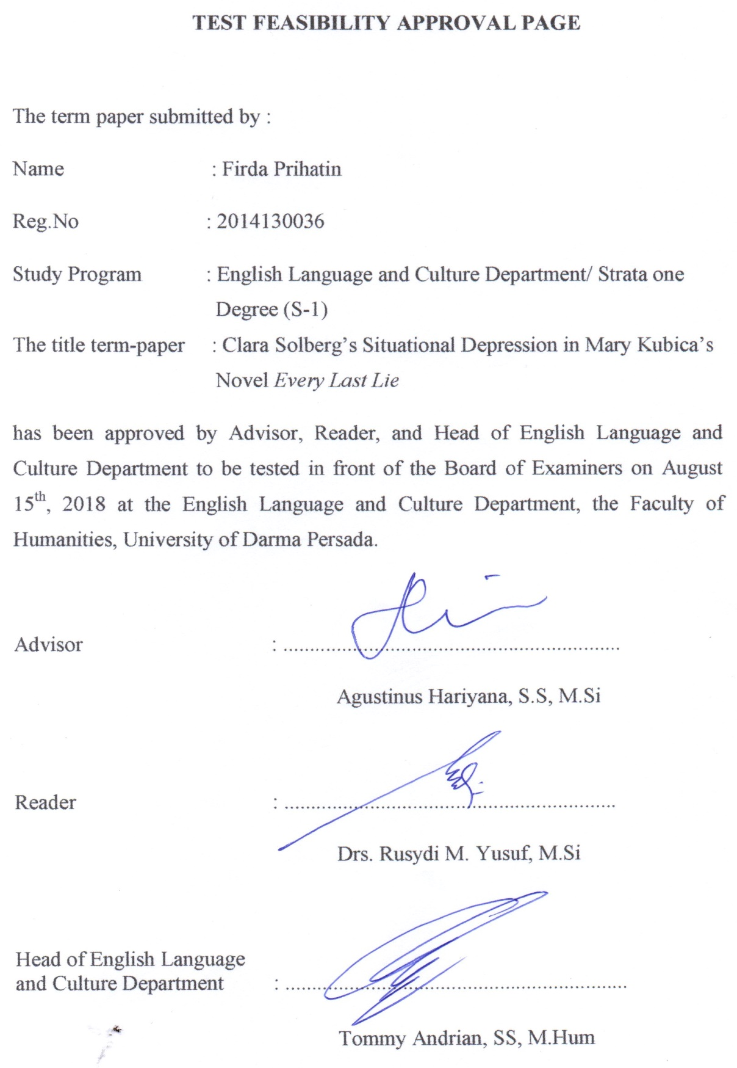

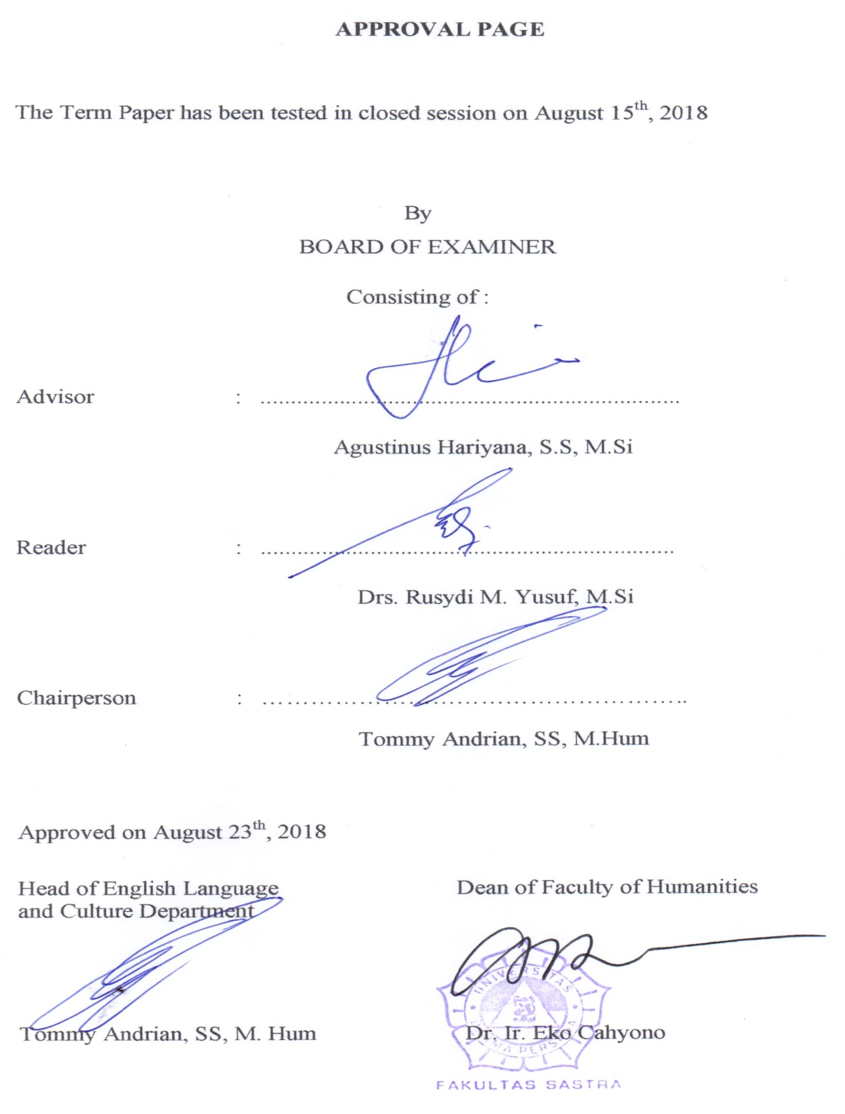

ACKNOWLEDGEMENT

Alhamdulillahi rabbil ‘aalamiin, praise be to Allah SWT who has given the mercy and blesses to me to be able to finish my term paper entitled Clara Solberg’s Situational Depression in Mary Kubica’s Novel Every Last Lie. This paper is submitted as a partial fulfillment of the requirements for obtaining the Strata One (S1) degree at the English Language and Culture Department, the Faculty of Humanities, University of Darma Persada.
Behind the making process of this term paper, there are many great people who always guide and support me from the beginning until I finish this term paper. Their advices are very helpful for me to finish this term paper.
By account of that, I would like to say a lot of gratitude to them, those great people are:
- Agustinus Hariyana, S.S, M.Si, as the adviser who guided me patiently in making my term paper.
- Drs. Rusydi M. Yusuf, M.Si, as the reader who has checked and corrected this term paper.
- Tommy Andrian, SS, M. Hum as the Head of English Language and Culture Department.
- Dr. Ir. Eko Cahyono, M.Eng. the Dean of Faculty of Humanities.
- All lecturers of English Language and Culture who have given me so much knowledge and experiences. The secretariat whom helped during I college at University of Darma Persada.
- The library and librarian who help me to find some books for support the sources of this term paper.
- My dear parent whom I adore so much. I would never be like this without both of you. Thank you so much, for always loving me unconditionally.
- My old sister Chynthia Debby, who support me though often scold me. My old bestfriend, Chintya Mega Monica, who gives me advice and always reminds me of Allah SWT in the most difficult times. My cousin Fahriza Adam Arighi, who always helped me in improving the format of writing this term paper, and my whole family who always loving me and cheer me up.
- My lovely senior Yuliana, SS, who helped me from the beginning of this term paper to almost finished. Siti Aisyah and Aryani Dwi Yuliana. My best friends who always exist and faithfully listen to my internal and external problems during writing this term paper. Eva, Widya, Uha, Aghnia, my friends who always support and encourage me. Elvira, Aulia, Dysa. My friends who always faithfully accompanied me during consultation time and given me supports. Jeanette Antonia Watuna, who lent me the book of Metodologi Penelitian.
- My beloved friends in SWARA UNSADA, especially 25, 26, 27, 28, who has taught me so much about organization and friendship.
Overall, I hope that Allah is pleased to give all the good of all those who have helped. I hope this term paper brings benefits to the next study.

Jakarta, August 15th, 2018

Writer

Firda Prihatin

ABSTRACT

Name : Firda Prihatin
Program of Study : English Language and Culture Department
Title : Clara Solberg’s Situational Depression in Mary Kubica’s Novel Every Last Lie

This term paper discusses the theme of literature in a novel by using two approaches, which are intrinsic and extrinsic approaches. In the intrinsic approach there are concepts; Characterization through direct and indirect method then plot and setting, and extrinsic approach there is a theory of psychology that is situational depression theory. This term paper discusses the character of Clara Solberg who has situational depression, which appears after her husband death. Sadness due to the death of a loved one is the foundation of the situational depression it has. The sense of loss she feel is the source of situational depression within her. In this research Every Last Lie Novel is the primary source and supported by related theories, concepts and definitions that combine secondary sources.

Keywords: Every Last Lie, Situational Depression, Clara Solberg

ABSTRAK

Nama : Firda Prihatin
Program Studi : Departemen Bahasa Inggris dan Budaya
Judul : Clara Solberg’s Situational Depression in Mary Kubica’s Novel Every Last Lie

Skripsi ini membahas tema karya satsra dalam sebuah novel dengan menggunakan 2 pendekatan, yaitu secara intrinsik dan ekstrinsik. Dalam pendekatan intrinsik terdapat konsep-konsep; Karakterisasi melalui metode langsung dan tidak langsung kemudian alur, latar, dan pendekatan ekstrinsik terdapat teori psikologi yaitu situational depression theory. Skripsi ini membahas karakter Clara Solberg yang memiliki situational depression, yang terlihat setelah suaminya meninggal. Kesedihan karena kematian orang yang dicintai merupakan dasar dari situasional depresi yang dimilikinya. Rasa kehilangan yang ia rasakan merupakan sumber situasional depresi yang ada didalam dirinya. Novel Every Last Lie merupakan sumber primer dalam skripsi ini dan didukung oleh teori-teori, konsep, dan definisi terkait yang menjadi sumber sekunder.

Kata kunci: Every Last Lie, Situational Depression, Clara Solberg

TABLE OF CONTENTS
INTELLECTUAL PROPERTY STATEMENT PAGE iii
TEST FEASIBILITY APPROVAL PAGE iv
APPROVAL PAGE v
ACKNOWLEDGEMENT vi
ABSTRACT viii
ABSTRAK ix
TABLE OF CONTENTS x

CHAPTER I: INTRODUCTION 1
A. Background of the Problem 1
B. Identification of the Problem 3
C. The Limitation of the Problem 3
D. The Formulation of the Problem 3
E. The Objectives of the Research 4
F. Methods of the Research 4
G. Benefit of the Research 5
H. The Systematic Organization of the Research 5

CHAPTER II: FRAMEWORK OF THEORIES 7
A. Intrinsic Approaches 7
- Characterization 7
- Plot 10
- Setting 11
B. Extrinsic Approaches 12
- Psychology in Literature 12
- Psychology of Personality 12
- Situational Depression 13

CHAPTER III: THE INTRINSIC ELEMENTS IN MARY KUBICA’S
EVERY LAST LIE NOVEL…………………………………………………. 14
A. Characterization 14
- Clara Solberg 14
- Nick Solberg 21
- Maisie 27
- Kat Ables 35
B. Plot 40
- Exposition 40
- Complication 42
- Crisis 44
- Falling action 46
- Resolution 47
C. Setting 49
1. Setting as a backgound of action 49
2. Setting as an antagonist 50
3. Setting as means of creating appropriate atmosphere 52
4. Setting as means of revealing character 54
5. Setting as reinforcing of theme 55

CHAPTER IV: CLARA SOLBERG’S SITUATIONAL
DEPRESSION …………………………………………... 58
A. Analysis of situational depression based on characterization 58
1. Clara Solberg’s situational depression through the characterization 59
2. Clara Solberg’s situational depression 73
3. Clara Solberg’s situational depression related by other characters 74
B. The relation of situational depression to the plot 75
C. The relation of situational depression to the setting 76
D. The situational depression in novel Every Last Lie 77

CHAPTER V: CONCLUSION 78
REFERENCES 80
SCHEME OF THE RESEARCH 82
POSTER OF THE RESEARCH 83
CURRICULUM VITAE 84
ATTACHMENT 85

