SCHEME OF THE RESEARCH

EVA SEPTIANI
2014130030
UNIVERSITY OF DARMA PERSADA
METHOD OF RESEARCH
This research uses qualitative method that use written data in the form of debate script that have been obtained and will be analyzed qualitatively by linking the theory with the data which already obtained with the example. The theories of politeness are Bald-On-Record, Positive Politeness, Negative Politeness, and Off-Record. The theories of FTA are FTAs Speaker’s and Hearer’s Negative Face, FTAs Speaker’s and Hearer’s Positive Face.
RESULT OF THE RESEARCH
In Face Threatening Acts in the First Presidential between Donald Trump and Hillary Clinton on 26th September 2016, the four politeness strategies and FTAs as is proposed are all employed. Negative Politeness is the most frequent strategy that used by Donald Trump with 47 times and Hillary Clinton with 41 times. Negative Face is the most frequent FTA that used by Donald Trump and Hillary Clinton with 72 and 48 times.
BENEFITS
This research is very useful for all of the people in the process of communication especially about utterances that they talk about that can threaten interlocutor’s face.
BACKGROUND
We use language as a tool to communicate. The concept of face is always used in the daily activity like in the process of communication. The concept of face is also used in the debate like presidential debate between Donald Trump and Hillary Clinton. Face has the meaning in the saying “to lose face”. Every participant in the social process has the need to be appreciated by others and the need to be free and not interfered with. Someone has a chance to be appreciated and accepted by others if they use positive face. If there is no positive face in the process of communication, someone will have a difficulty to be appreciated and accepted by others. Through negative face, someone has a chance not to be disturbed by others. If there is no negative face in the process of communication, someone will be easier to be disturbed by others.
FRAMEWORK OF THE THEORIES
In analyzing this research, the write uses the theory that support the analysis which is Politeness Strategies includes Bald-On-Record, Positive Politeness, Negative Politeness, Off-Record and FTA include Positive Face and Negative Face.

FACE THREATENING ACTS IN THE FIRST PRESIDENTIAL DEBATE BETWEEN DONALD TRUMP AND HILLARY CLINTON ON 26TH SEPTEMBER 2016: A STUDY OF PRAGMATICS

Curriculum Vitae


Personal Data

Name : Eva Septiani
Nationality : Indonesian
Sex : Female
Place/Date of Birth : Banyumas, 13 September 1996
Religion : Islam
Address : Perumahan Gramapuri
Tamansari Blok E3 No 9
Cibitung 17520
Mobile / Phone : 089637662168
Email : evaseptiani96@gmail.com

Educational Background
2002-2008 : Sekolah Dasar Negeri 15, Bekasi
2008-2011 : Sekolah Menengah Pertama Tridaya Sakti
2011-2014 : Sekolah Menengah Atas Negeri 2 Tambun Selatan
2014-Present : Universitas Darma Persada, Jakarta

Achievements
      - Certificate of Intermediate Levels in LBPP LIA 2014
      - Certificate of iLearn@america Academic and Businees Writing 2015
      - Participant of The ASEAN Way Photo Competition 2017
      - Certificate TOEIC 2018
      - Participant 4th Annual ASEAN Youth Video Contest 2018
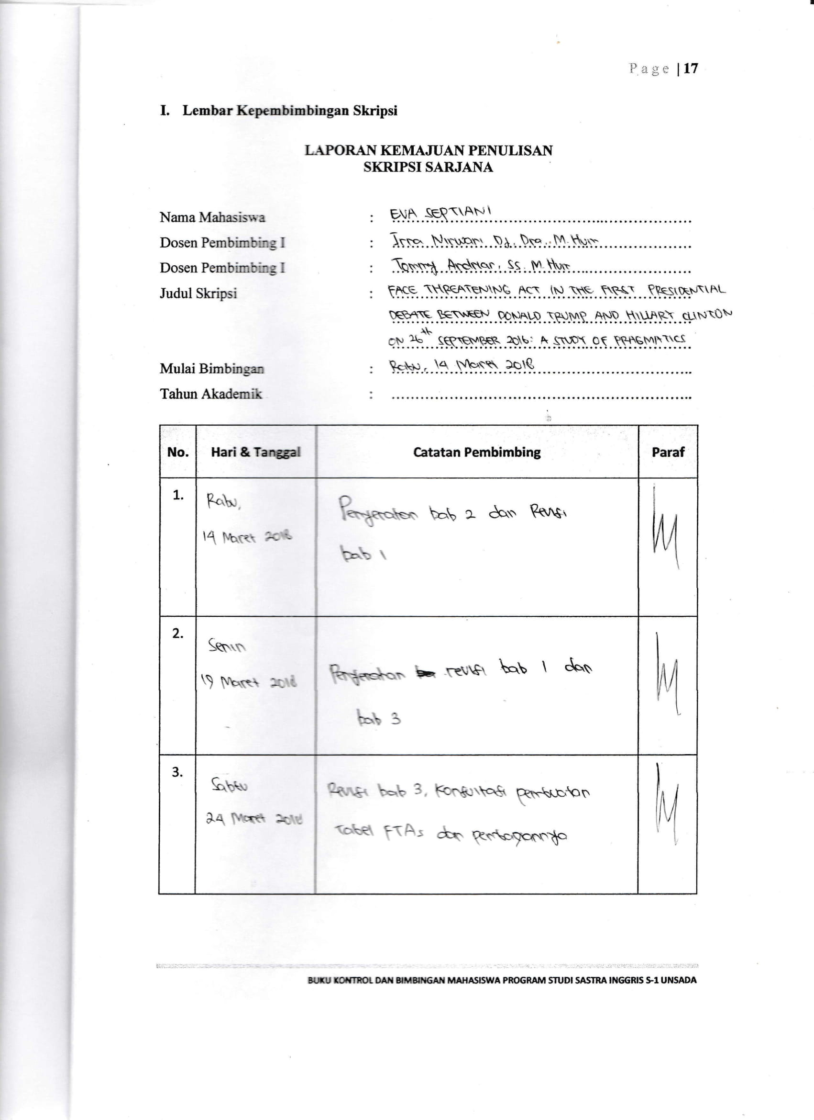
ATTACHMENTS

