THE REFLECTION OF SELF-ACTUALIZATION IN AMANDA QUICK’S NOVEL THE GIRL WHO KNEW TOO MUCH

TERM PAPER



KAMILIA NAZHARA
2015130037

STRATA ONE (S-1) OF ENGLISH LANGUAGE AND CULTURE
FACULTY OF HUMANITIES
DARMA PERSADA UNIVERSITY
JAKARTA
2019

THE REFLECTION OF SELF-ACTUALIZATION IN AMANDA QUICK’S NOVEL THE GIRL WHO KNEW TOO MUCH

TERM PAPER
Submitted in Part Fulfilling for Obtaining
Strata One (S-1) Degree

KAMILIA NAZHARA
2015130037

STRATA ONE (S-1) OF ENGLISH LANGUAGE AND CULTURE
FACULTY OF HUMANITIES
DARMA PERSADA UNIVERSITY
JAKARTA
2019
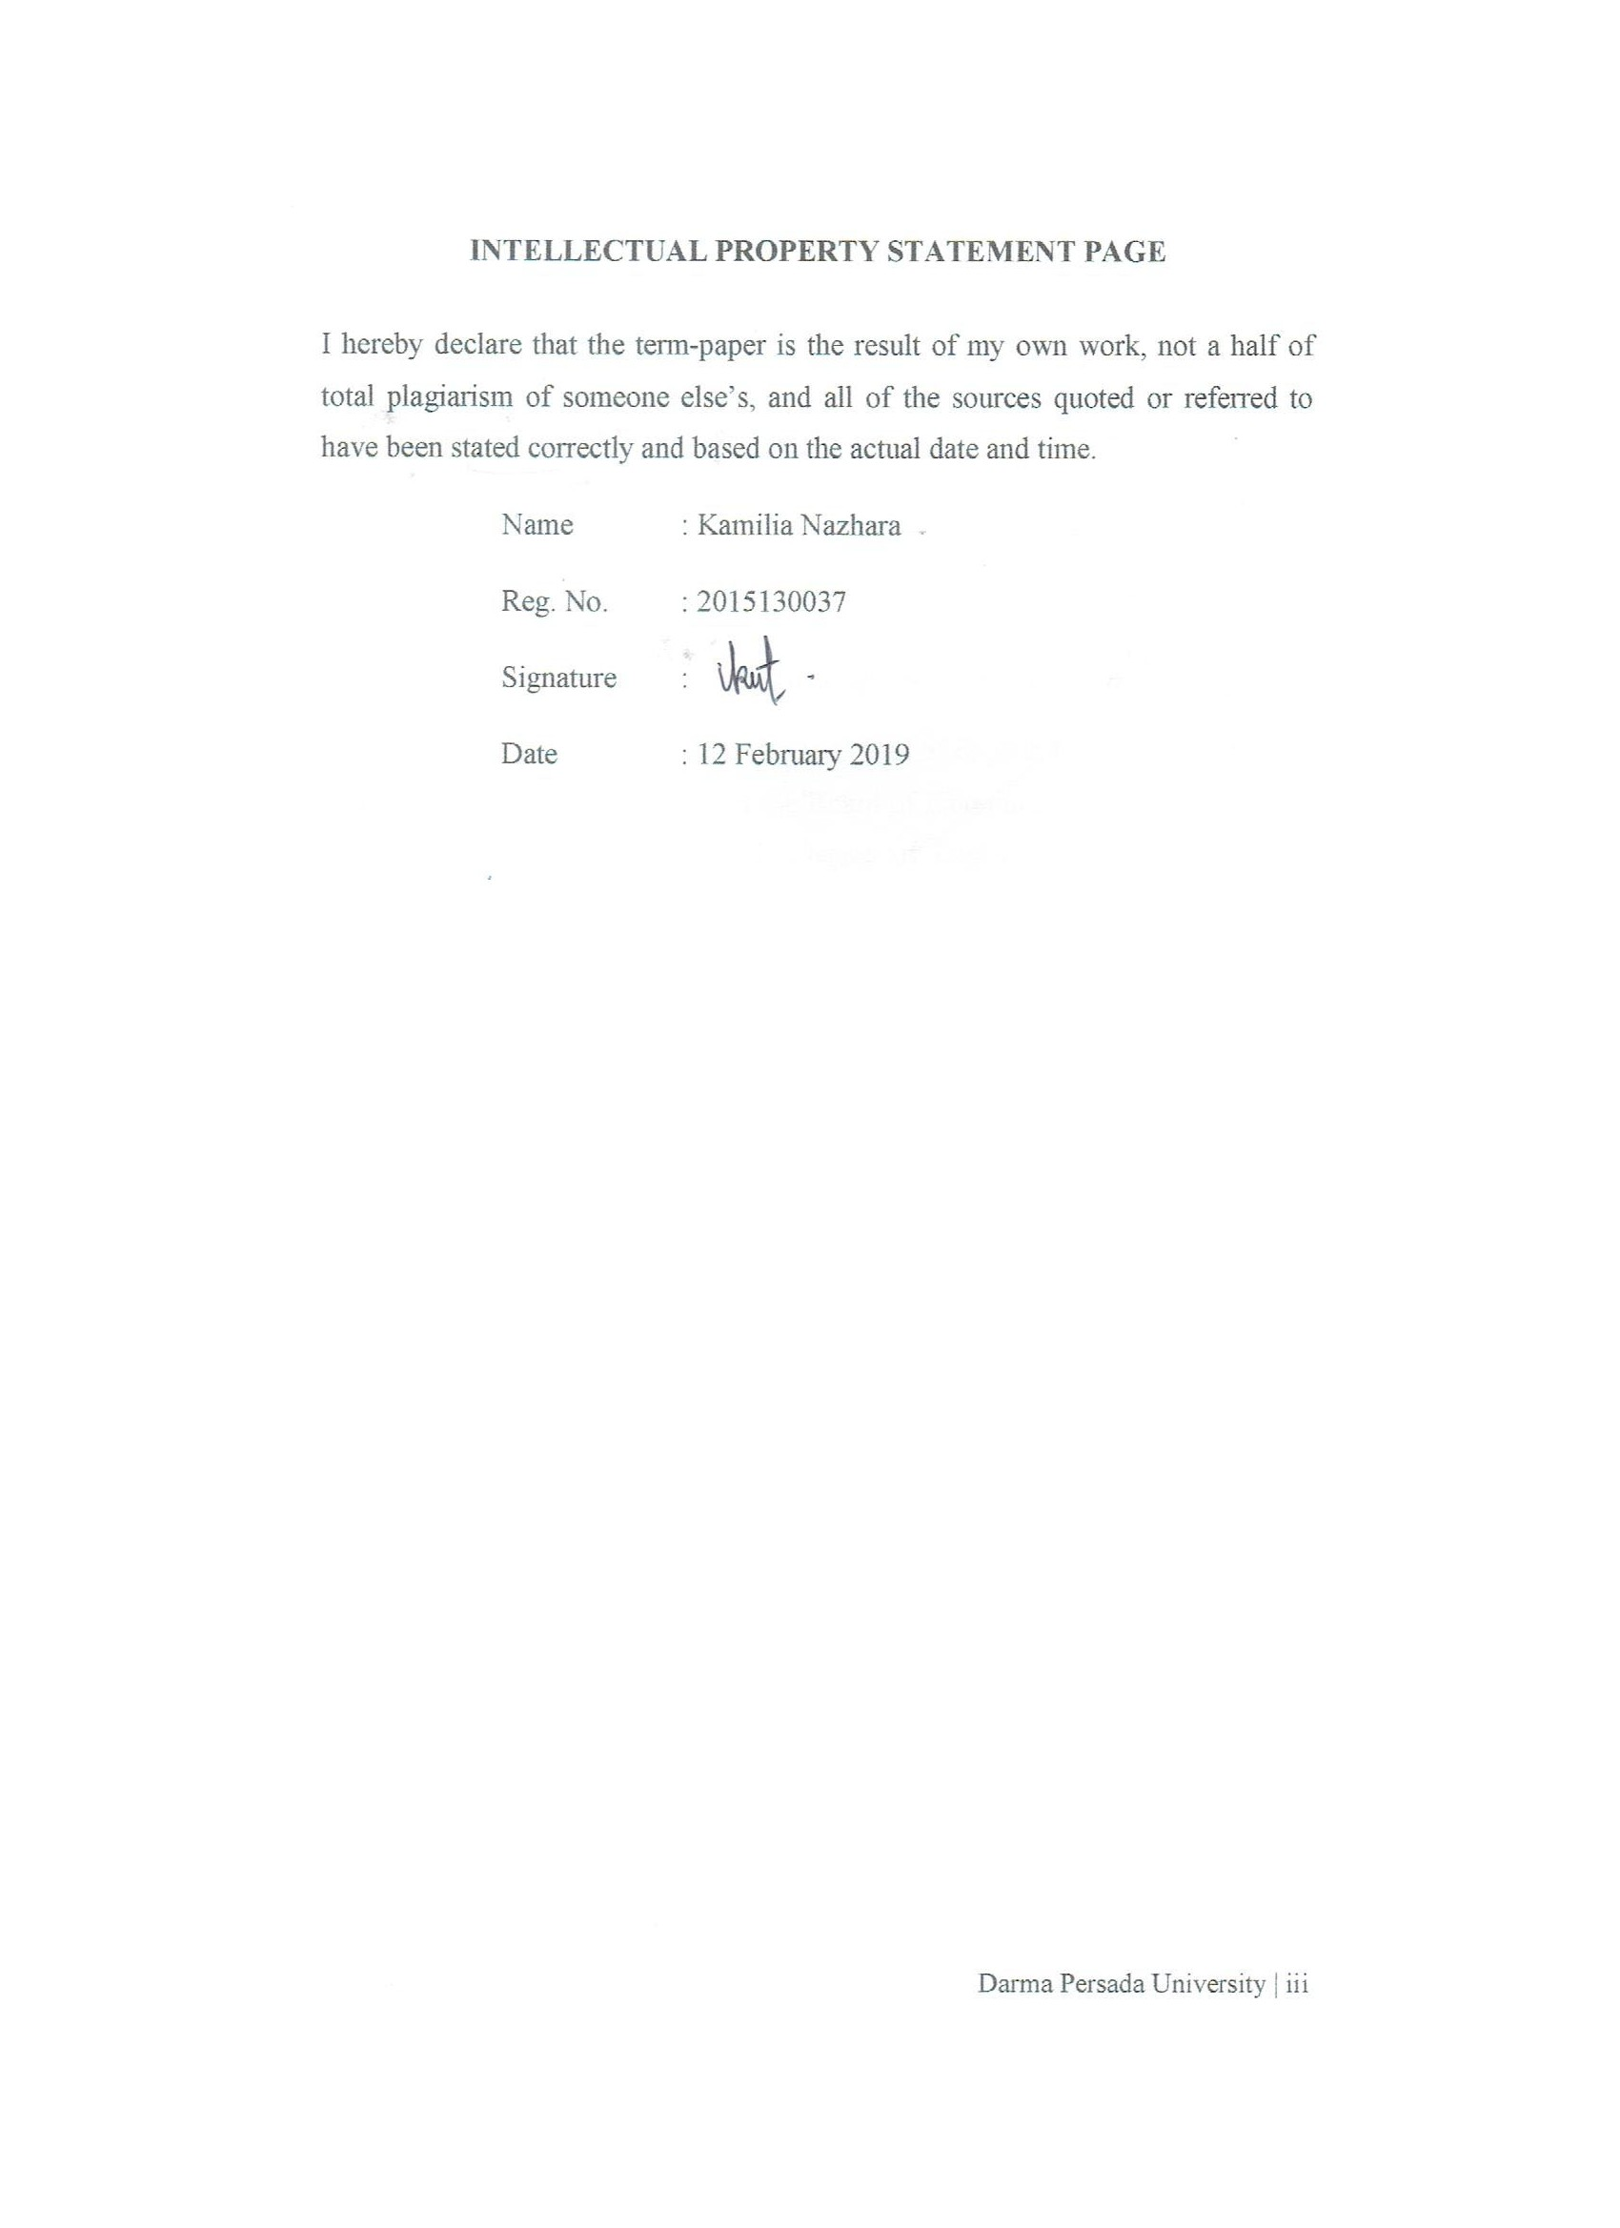

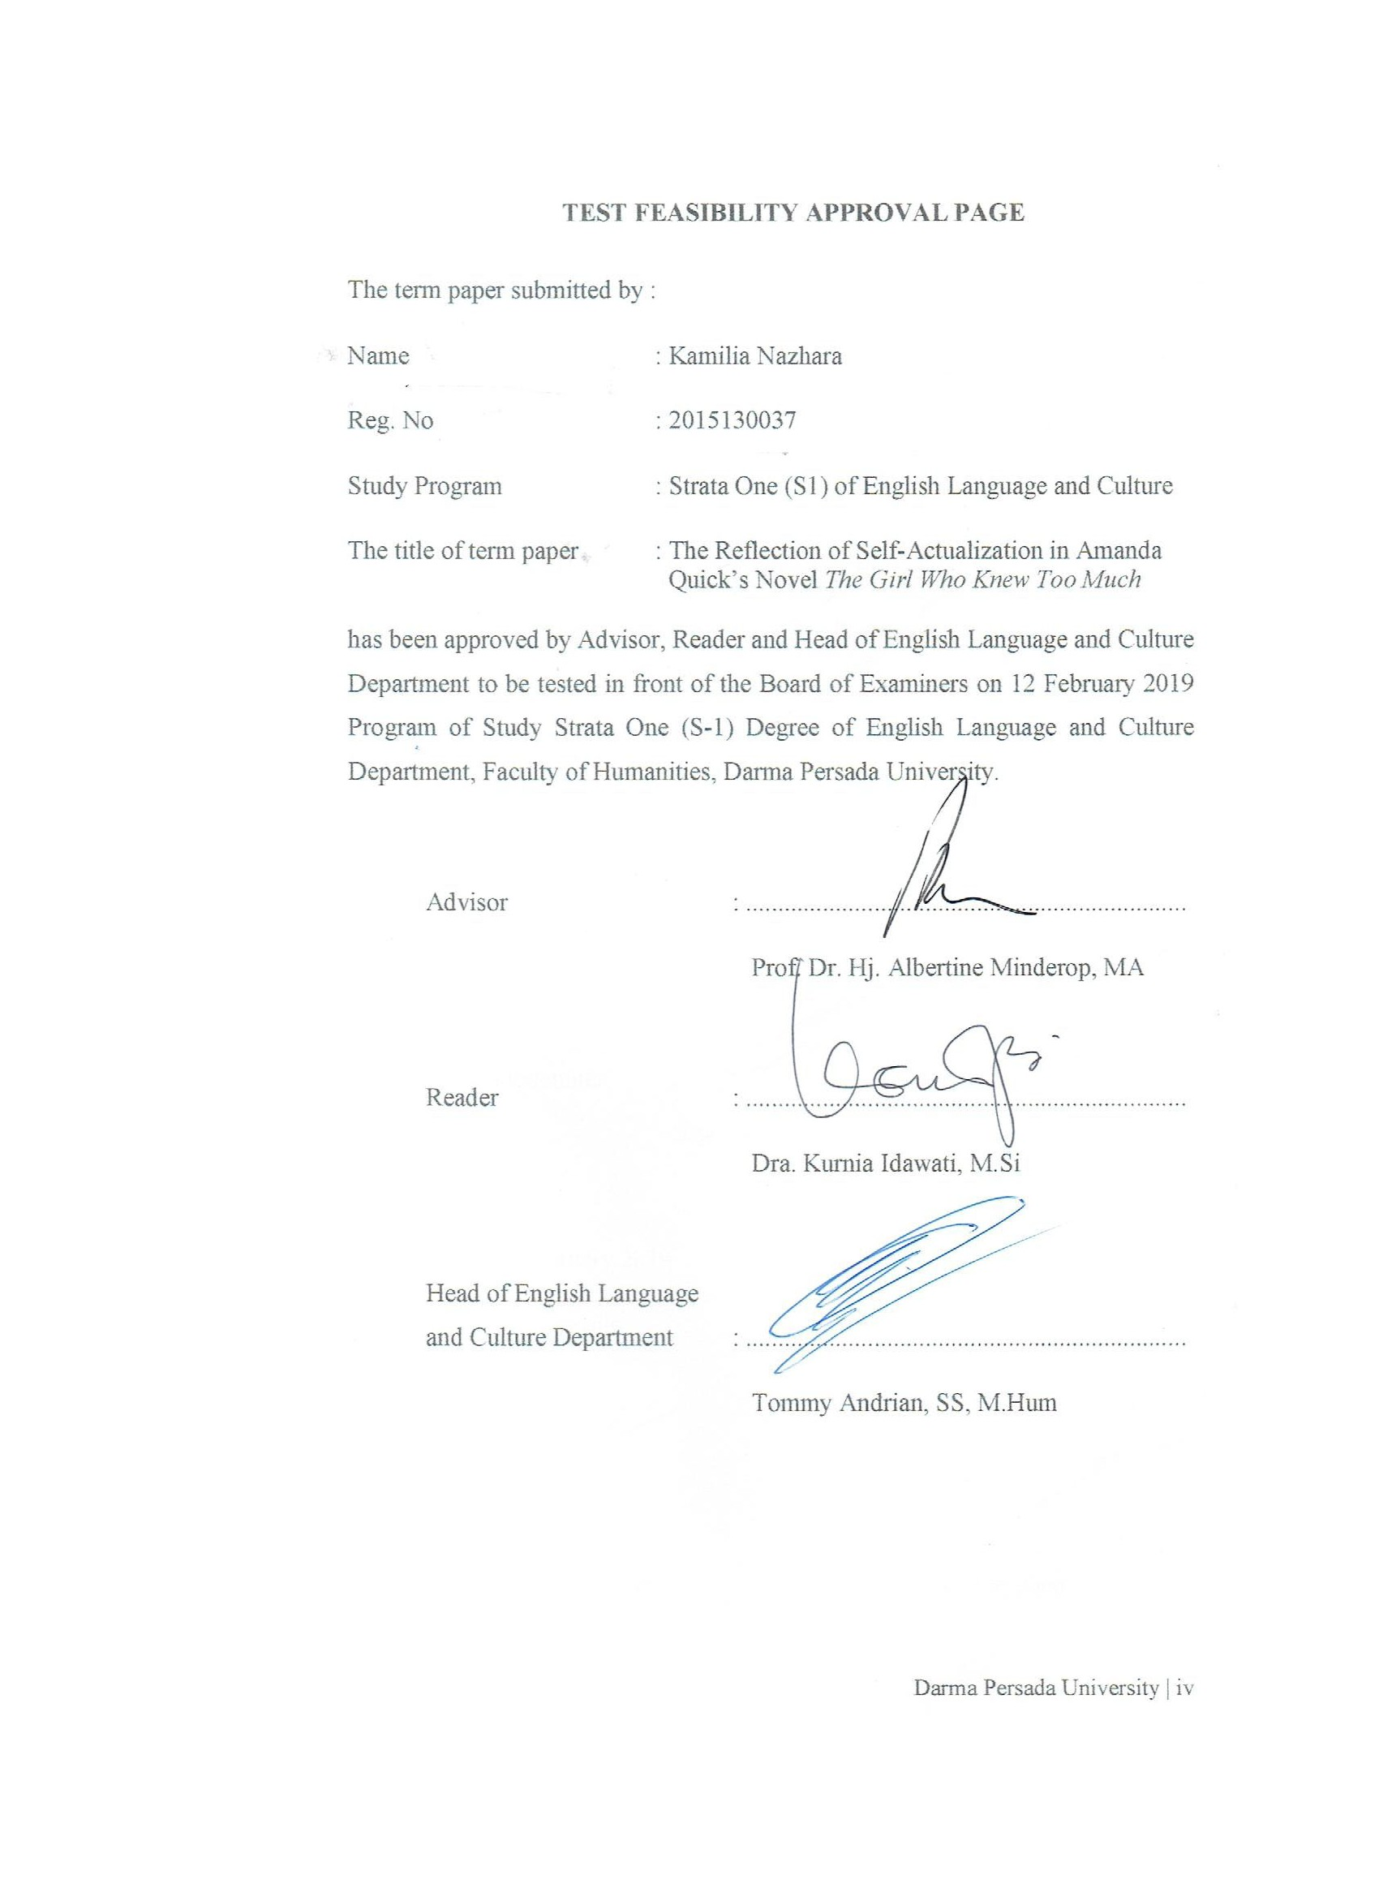

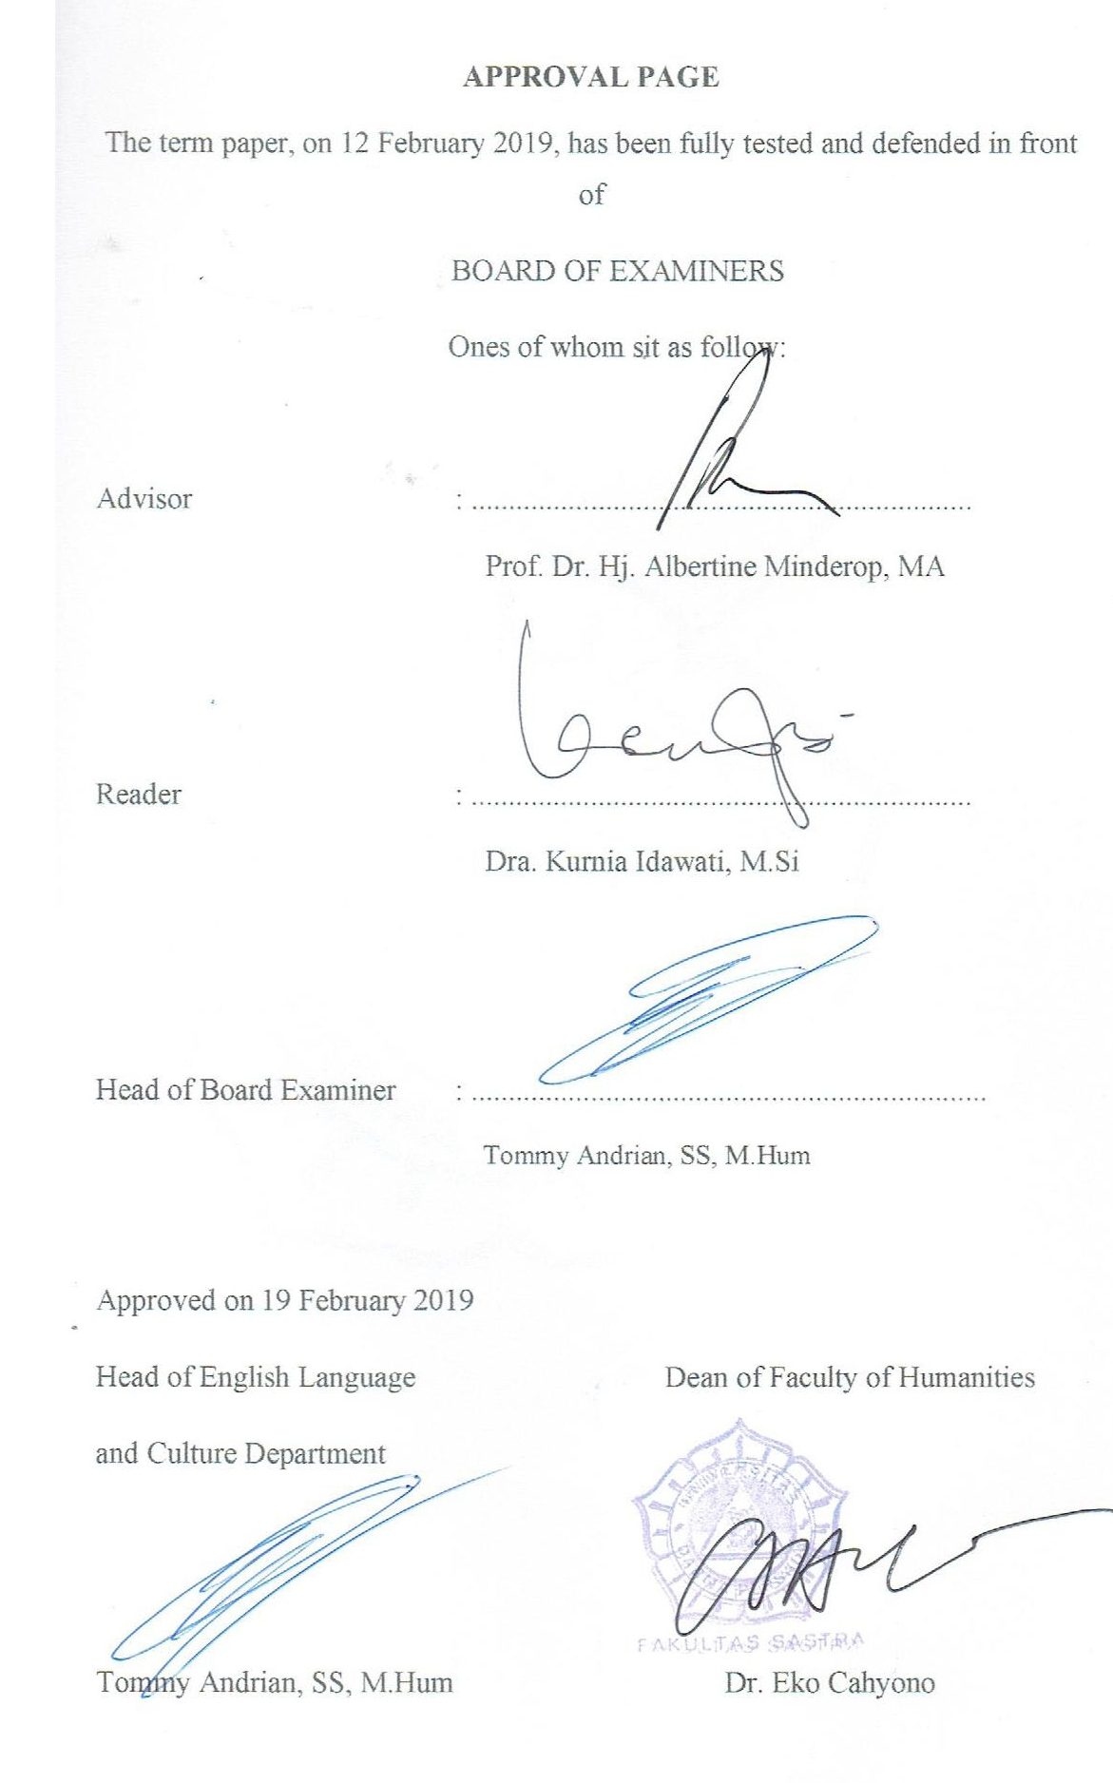

ACKNOWLEDGEMENT

Praise be to the Almighty God for His mercy and blessing, finally I could complete this term-paper well, which entitled The Reflection of Self-Actualization in Amanda Quick’s Novel The Girl Who Knew Too Much. This term-paper is submitted to the Strata One English Department of Darma Persada University as a partial fulfillment of the requirements for obtaining the Strata One (S-1) degree.
I would like to thank to all parties who have guided and supported me in finishing this term-paper, my appreciation is delivered to those who give contribution in completion of this term-paper, which I listed as follows:
- I would like to express my sincere gratitude to my advisor Prof. Dr. Hj. Albertine Minderop, MA for the continuous support of my term-paper, motivation, and immense knowledge.
- Dra. Kurnia Idawati, M.Si as the Reader who has checked and corrected the word by word thoroughly in this term-paper, also for the encouragement and insightful comments.
- Tommy Andrian, SS, M.Hum as the Head of English Language and Culture Department.
- Dra. Karina A. Sulaeman, MA as my Academic Advisor who has guided and
helped me patiently in the preparation of my study every semester.
- All lecturers of English Language and Culture Department who have given me so much knowledge and experiences.
- To my parents, this journey would not possible without the support of both of you. Thank you for encouraging and inspiring me to follow my dreams. I always knew that you believed in me and wanted the best for me.
- My sisters, Dita and Rani, for your encouragement, moral support, personal attention and care. It means a lot for me.
- My dear nephews and nieces, Sadam, Kinan, Sabrina and Qiano, for being my stress relieve pills. You all are the sweetest and cutest things surrounding me.
- A special thanks to Ronny Meldika Arviansyah, the person who always helped me in doing my term-paper. You have been extremely supportive through all the difficulties.
- My best partner in Asian Games, Agung Cahya, for listening and supporting me through this entire process.
- My best friends, Mega, Bella and Ricky who always color my days and give me many useful advices. You guys are the best.

This term-paper is far from perfection. Suggestions and constructive criticism are welcome.

Jakarta, 31 January 2019
Writer

Kamilia Nazhara

ABSTRACT

Name : Kamilia Nazhara
Program of Study : English Language and Culture
Title : The Reflection of Self-Actualization in Amanda Quick’s
Novel The Girl Who Knew Too Much

The issue raised in this term-paper is about the reflection of self-actualization. Two approaches, intrinsic and extrinsic approaches, are applied to analyze this novel. The concepts that is applied to analyze through intrinsic approach consists of characterization by using telling and showing methods, plot and setting. The concept to analyze through extrinsic approach is the theory of self-actualization by Abraham Maslow. This research explains about the reflection of self-actualization in one character, Irene Glasson, as well as its relation to other intrinsic elements. In this research, The Girl Who Knew Too Much novel is the primary sources and supported by some of relevant theories, concepts, and definitions which as secondary sources.
Keywords: Hierarchy of Needs, Self-Actualization, Characterization, Plot, Setting

ABSTRAK

Nama : Kamilia Nazhara
Program Studi : Bahasa dan Budaya Inggris
Judul : The Reflection of Self-Actualization in Amanda Quick’s
Novel The Girl Who Knew Too Much

Masalah yang diangkat dalam skripsi ini adalah mengenai cerminan aktualisasi diri. Dua pendekatan, pendekatan intrinsik dan ekstrinsik, digunakan untuk menganalisis novel ini. Konsep-konsep yang digunakan untuk menganalisis melalui pendekatan intrinsik meliputi karakterisasi melalui metode langsung dan tidak langsung, alur dan latar. Konsep untuk menganalisis melalui pendekatan ekstrinsik adalah teori aktualisasi diri dari Abraham Maslow. Penelitian ini membahas tentang cerminan aktualisasi diri dalam satu karakter, Irene Glasson, serta kaitannya dengan unsur-unsur intrinsik lainnya. Dalam penelitian ini, Novel The Girl Who Knew Too Much merupakan sumber primer dalam skripsi ini dan didukung oleh teori-teori, konsep dan definisi terkait yang menjadi sumber sekunder.
Kata Kunci: Hierarki Kebutuhan, Aktualisasi Diri, Karakterisasi, Alur, Latar

Table of Contents
INTELLECTUAL PROPERTY STATEMENT PAGE iii
TEST FEASIBILITY APPROVAL PAGE . iv
APPROVAL PAGE v
ACKNOWLEDGEMENT vi
ABSTRACT viii
ABSTRAK ix
CHAPTER I : INTRODUCTION 1
A. Background of the Problems 1
B. Identification of the Problems 2
C. Limitation of the Problems 3
D. Formulation of the Problems 3
E. Objectives of the Research 3
F. Method of the Research 4
G. Benefit of the Research 4
H. The Systematic Organization of the Research 4
CHAPTER II : FRAMEWORK OF THE THEORIES 6
A. Intrinsic Approaches 6
1. Characterization 6
a. Telling Method 6
b. Showing Method 7
2. Plot 9
a. Exposition 9
b. Complication 9
c. Crisis 9
d. Falling Action 9
e. Resolution 9
3. Setting 9
a. Setting as a Background of Action 10
b. Setting as an Antagonist 10
c. Setting as a Means of Revealing Character 10
B. Extrinsic Approaches 10
1. Psychology in Literature 10
2. Humanistic Psychology 11
3. Maslow’s Hierarchy of Needs 11
CHAPTER III : THE NOVEL THE GIRL WHO KNEW TOO MUCH THROUGH INTRINSIC APPROACHES 15
A. Characterization 15
1. Irene Glasson 15
2. Oliver Ward 24
3. Nick Tremayne 28
4. Claudia Picton 32
B. Plot 35
1. Exposition 35
2. Complication (Rising Action) 37
3. Crisis 38
4. Falling Action 42
5. Resolution 44
C. Setting 46
1. Setting as a Background of Action 46
2. Setting as a Means of Revealing Character 47
3. Setting as an Antagonist 49
CHAPTER IV : THE REFLECTION OF SELF-ACTUALIZATION IN IN THE NOVEL THE GIRL WHO KNEW TOO MUCH 52
A. Physiological Needs 52
1. The Relation of Physiological Needs to Characterization 52
2. The Relation of Physiological Needs to the Plot 53
3. The Relation of Physiological Needs to the Setting 56
B. Safety Needs 56
1. The Relation of Safety Needs to the Characterization 56
2. The Relation of Safety Needs to the Plot 59
3. The Relation of Safety Needs to the Setting 61
C. Love and Belonging Needs 62
1. The Relation of Love and Belonging Needs to the Characterization ………………………………………………………………….. 62
2. The Relation of Love and Belonging Needs to the Plot 64
3. The Relation of Love and Belonging Needs to the Setting 66
D. Esteem Needs 67
1. The Relation of Esteem Needs to the Characterization 67
2. The Relation of Esteem Needs to the Plot 69
3. The Relation of Esteem Needs to the Setting 71
E. Self-Actualization 72
1. The Relation of Self-Actualization to the Characterization 72
2. The Relation of Self-Actualization to the Plot 78
3. The Relation of Self-Actualization to the Setting 80
F. Summary 82
CHAPTER V : CONCLUSION 83
REFERENCES 85
SCHEME OF THE RESEARCH 87
ATTACHMENTS 88

